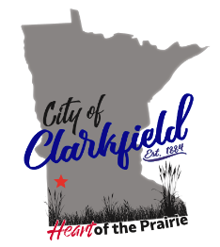
Agenda
5:30 PM / EDA Public Hearing
Monday, November 20th, 2023
City Hall Meeting Room
904 10th Avenue Clarkfield, MN 56223

A public hearing was called to order at 530 Pm on Nov 11th, 2023.

EDA Board members in attendance Sue Fritz, Darrin Johnson, Lisa Tilney,
Public: Dale Stringer Jr. Tim Pehrson, Betsy Pardick, Craig Giles, Sues husband.

Before the public hearing was called to order Sue Fritz went over the rules to a public hearing.

- CALL TO ORDER – PUBLIC HEARING – SALE OF PROPERTY
The meeting was called to order at 5:32 PM.
Sue – Read the mission statement that was submitted by the potential buyers of the Clarkfield State Bank
  - Sale of Clarkfield State Bank building at 949 10th Street
  - Terms of Sale
Sue read EDA Resolution No. 2023-2
    - Public Comments
Dale Stringer – inform the citizens of how much the city has spent on this building.
Darrin Johnson – wanted it clarified if it was bought using city tax dollars or EDA money.
Sue – it is an EDA owned property.
Dale – I was under impression that EDA money is City money.
Sue – originally the EDA was started by the city but it runs on the revenue generated by the apartments.
The EDA will meet
- ADJOURN PUBLIC HEARING
Meeting is adjourned at 5:41 PM

